Transform Your Textiles
You don’t need a sewing machine to make:-
- A rag wrath – you just needs lots of fabric!
- Scrap fabric Christmas baubles http://sewing.craftgossip.com/tutorial-scrap-fabric-ornaments/2014/11/22/
- Birthday cards with a row of bunting
- Dusters
- Gift wrapping, try out the Japanese method of furoshiki
- Rag rugs https://www.youtube.com/watch?v=XGjSLhal0Uc
- Rag curlers for long hair (popular in our house!)
- Fleece Tug Dog Toy (you can use old t shirts or denim instead) http://makingithomeblog.com/tutorial-fleece-tug-toy-dogs/
- Dream Catchers
- Woven Rug using a hoola hoop http://wonderfuldiy.com/wonderful-diy-hula-hoop-woven-rug-from-old-shirts/
- T shirt yarn for crochet and knitting projects http://www.allfreecrochet.com/Tutorials/T-Shirt-Yarn-Tutorial
- No sew T Shirt bags http://www.mommypotamus.com/no-sew-t-shirt-tote-bag-tutorial/
- CD Coasters http://vickymyerscreations.co.uk/tutorial-2/cd-coasters/

Quick and Easy Sewing Ideas
- Dressing up cape – unpick the back seam of a skirt, thread elastic through the waist band and gather up to suitable size.
- Cushion covers from shirts
- Bottle Holders from sleeves of shirts
- Mobile phone cases, how about using an old tie - http://vickymyerscreations.co.uk/tutorial-2/make-your-own-phone-case/
- An infinity scarf from a skirt - http://vickymyerscreations.co.uk/tutorial-2/infinity-scarf-tutorial-upcycled-skirt/
- Hot water bottle cover from an old sweater
- Fabric flower tutorial http://vickymyerscreations.co.uk/tutorial-2/scrap-fabric-flower-tutorial/
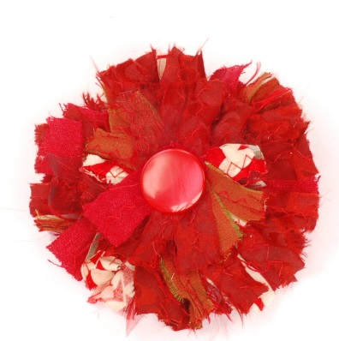
Have some time? How about trying:-
- Messenger bag made from a man’s jacket http://www.craftsonsea.co.uk/upcycled-messenger-bag-tutorial/
- Denim foot pouf http://vickymyerscreations.co.uk/tutorial-2/recycled-denim/
- Rag quilt http://vickymyerscreations.co.uk/tutorial-2/diy-denim-rag-quilt/
- Transform a pleated tweed skirt into a bag http://www.craftsonsea.co.uk/upcycled-messenger-bag-tutorial/

